Volunteers’ Management System
Risk Management Plan
Technical Challenge Project Course

Apollo Group

Revision History
Date | Version | Description | Author
12 February 2010 | 0.1 | Draft version of plan created

Table of Contents
1. Introduction 4
2. Risk Management Tasks 4
3. Organization and Responsibilities 4
4. Tools and Techniques 4

Risk Management Plan

1. Introduction
This document describes the plan of managing the risks that could appear during this project (Technical Challenge Course).

2. Risk Management Tasks

The initial risk list for the project will be identified in two ways; first: by the brainstorm session. When the tasks are assigned to the members, each member will identify some risks that could be happened during his/her task. So some expected risks could be avoided during the work.

Second, during the progress of the tasks, some types of risks will appear that could be noticed from the team as real risks. These risks could be similar to what they expected or other unforeseen risks. Also the intensity of the risks will be different from one to another.
They can also provide contingency plans or ways of transferring risk to other organizations. It’s obligatory for each member to provide criteria which will determine whether risk is happened or not. All the risks should be prioritized. Calculation of risk exposure will be the base approach to prioritize risks in this project. Here are definitions and formula to calculate the risk exposure.
- Impact of risk: The deviations of schedule, effort, or costs from plan if the risk occurs
- Likelihood of Occurrence: The probability that the risk will actually occur (usually expressed as a percentage)
- Risk Exposure = (Impact) * (Likelihood of Occurrence)

3. Organization and Responsibilities
All members are responsible to identify risks and analyze them throughout the project.

4. Tools and Techniques
A MS Excel file named “RiskList.xls” will be the repository of all risks in project. It means all risks with all specifications and analysis results will be managed in this file. Column titles for the table are as followings:
- Risk name
- Indicator
- Impact
- Probability
- Exposure
- Action
- Status

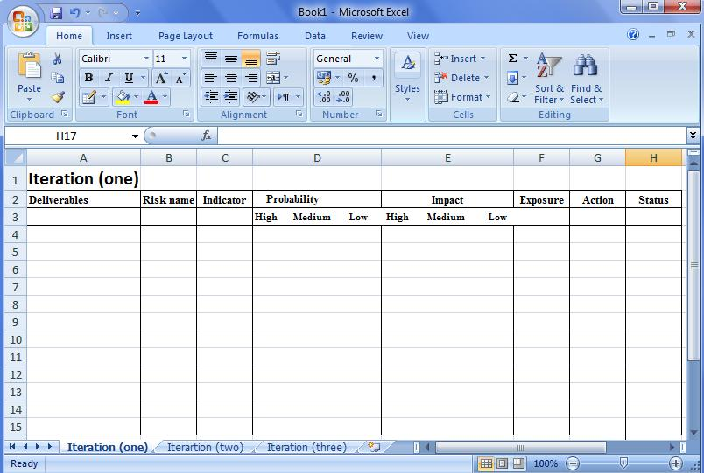

Table shows the tracking of risks in every iteration Figure (1).

Definitions and calculation formula extracted from RUP documents.

